34.40: a) 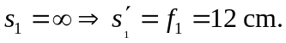
b) 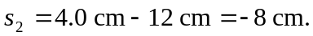
c) 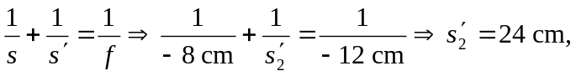to the right.
d)
